CH-O-0400-1402 * CH-O-(0100~0400)-1402 is a Hall-Effect current transducer.
I_{PN} =400A
V_{OUT} = 0…±10V
Current Transducer * It can be used for the detection of DC, AC, pulse.
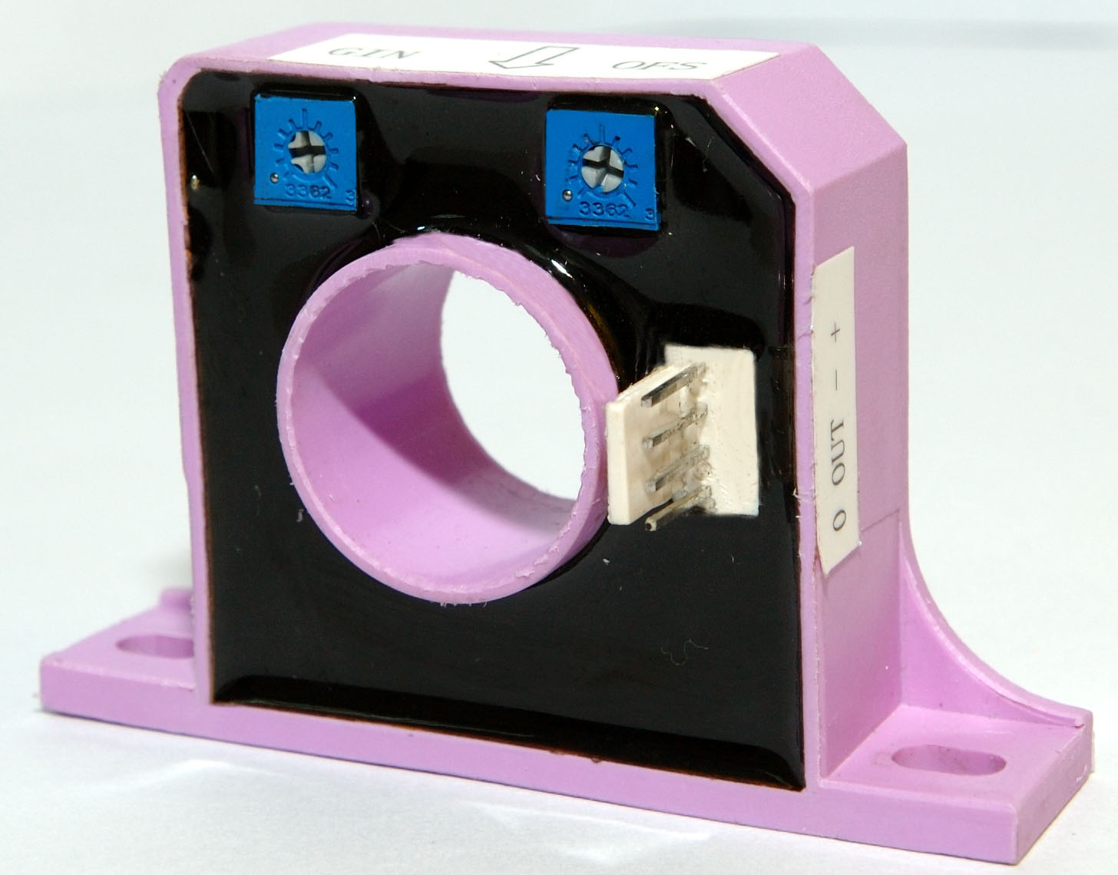
Advantages
- Easy mounting.
- Small size and space savings.
- Only one design for wide current ratings range.
- High immunity against external interference.
- Current overload capability.
- Adjustable output gain.
- Adjustable offset to zero.

Features
- Hall effect measuring principle.
- Galvanic isolation between primary and secondary circuit.
- Low power consumption.

Applications
- AC motor speed control.
- Static converters for DC motor drives.
- Battery supplied applications.
- Uninterruptible Power Supplies (UPS).
- Power supplies for welding, cable TV and telecommunication applications.

Electrical data
I_{PN} | Primary nominal r.m.s current |  |  |  | 400 | A
I_{P} | Primary current, measuring range |  |  |  | ± 1000 | A
VSN | Sensitivity |  |  |  | 4 V  V
V_{C} | Supply voltage (± 5%) |  |  |  | ±15 | V
I_{C} | Idle current consumption |  |  |  | < 20 | mA
V_{d} | AC isolation test, 50 Hz, 1min  R_{M max} |  |  |  | 2.5 | kV
R_{IS} | Isolation resistance @ 500 VDC  0  22 |  |  |  | > 500 | MΩ
V_{OUT} | Output voltage @ ± I_{PN}, R_{L} = 10 kΩ, T_{A} = 25°C |  |  |  | 0…± 10 | V
R_{L} | Load resistance |  |  |  | ≥ 10 | kΩ

Accuracy – Dynamic performance data
X | Accuracy @ I_{PN} , T_{A} = 25°C (without offset) | < ± 1 | %
ε_{L} | Linearity (0.. ± I_{PN}) | ≤ ± 1 | %of I_{PN}
V_{OE} | Electrical offset voltage @ I_{P} = 0, T_{A} = 25°C  @±100 A_{max}  0  0 | < ± 20 | mV
V_{OH} | Hysteresis offset voltage @ I_{P} = 0;
 | after an excursion of 3 × I_{PN} | < ± 30 | mV
V_{OT} | Thermal drift of V_{OE} | < ± 1 | mV/℃
t_{r} | Response time @ 90% of I_{P} | < 10 | μs
di/dt | di/dt accurately followed | > 50 | A/μs
f | Frequency bandwidth (-3 dB) | DC…50 | kHz

General data
T_{A} | Ambient operating temperature |  | -10..+100 | °C
m | Mass |  | 75 | g

SECONDARY TERMINALS
TERMINAL +: SUPPLY VOLTAGE+15V
TERMINAL -: SUPPLY VOLTAGE- 15V
TERMINAL OUT : OUTPUT MEASURE
TERMINAL 0: 0V

Adjustment

OFS : Zero offset adjust
GIN : Output amplitude adjust

Direction of use:
Precaution - Nominal current measuring range: 100 A ~ 400 A (AC) or 100 A ~ 400 A (DC).
Output voltage: 0 ~ ±10V.
Or output current:0～20mA.
If the above-stated condition is fulfilled, go to following steps:
Put the conducting wire through the center hole of the current transducer.
Connected the transducer as the pictures shown.
Adjust the OFS to obtain a zero offset output voltage if offset is non-zero. (EX-Factory is zero offset)
Adjust the GIN to obtain a desire maximum output voltage. (EX-Factory is 4V typical)

