I_{PN} = 350mA
V_{OUT} = 0…±2V
Current Transducer CH-O-0001-0401
* CH-O-0001-0401 is a Hall-Effect current transducer.
* It is used for the detection of DC ,AC ,pulse.
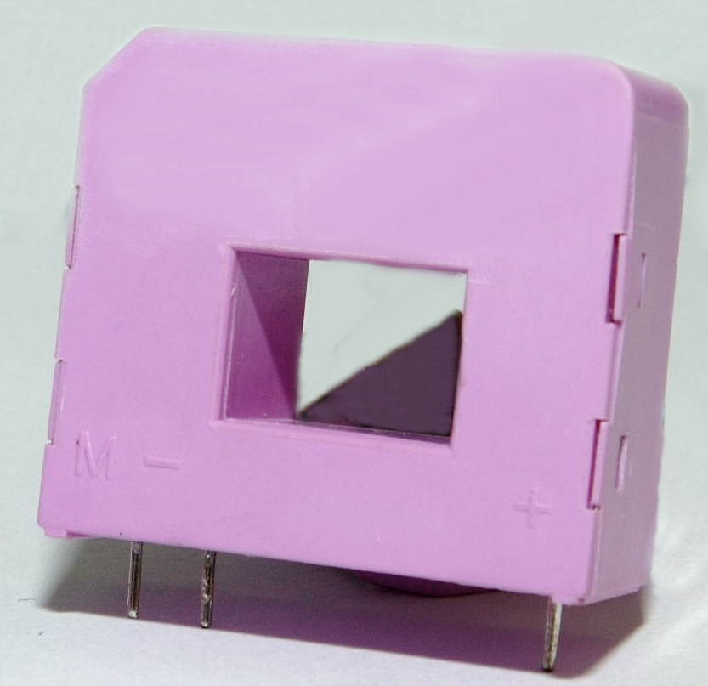

Electrical data
I_{PN} | Primary nominal r.m.s current | 350 | mA
I_{P} | Primary current, measuring range | ± 700 | mA
V_{C} | Supply voltage (± 5%) | +5 | V
I_{C} | Idle current consumption | <±20 | mA
V_{d} | AC isolation test, 50/60 Hz, 1min  R_{M max} | 3 | kV
R_{IS} | Isolation resistance @ 500 VDC | >500 | MΩ
V_{OUT} | Output voltage @ ± I_{PN}, R_{L} = 10 kΩ, T_{A} = 25°C | 0...±2 | V
R_{L} | Load resistance | ≥10 | kΩ

Accuracy – Dynamic performance data
X | Accuracy @ I_{PN} , T_{A} = 25°C (without offset) | < ± 1 | %
ε_{L} | Linearity (0.. ± I_{PN}) | <± 1 | %of I_{PN}
V_{OE} | Electrical offset voltage ,T_{A} = 25°C  @±100 A_{max}  0  0 | <±20 | mV
V_{OH} | Hysteresis offset voltage @ I_{P} = 0;
 | after an excursion of 3 × I_{PN} | < ± 30 | mV
V_{OT} | Thermal drift of V_{OE} | <± 1 | mV/℃
t_{r} | Response time @ 90% of I_{P} | <3 | μs
di/dt | di/dt accurately followed | >100 | A/μs
f | Frequency bandwidth (-3 dB) | 3 | kHZ

General data
T_{A} | Ambient operating temperature |  | - 20 ... + 80 | °C
m | Mass |  |  | g

Features
- Hall effect measuring principle.
- Galvanic isolation between primary and secondary circuit.
- Low power consumption.
- Printed circuit board mounting.

Advantages
- Easy mounting.
- Small size and space savings.
- Only one design for wide current ratings range.
- High immunity against external interference.
- Current overload capability.

Applications
- AC motor speed control.
- Static converters for DC motor drives.
- Battery supplied applications.
- Uninterruptible Power Supplies (UPS).
- Power supplies for welding, cable TV and telecommunication applications.

Direction of use:
Precaution - Output voltage: 0 ~ ±2V.
Or output current: 0～20mA.
If the above-stated condition is fulfilled, go to following steps:
Put the conducting wire through the center hole of the current transducer.
Connected the transducer as the pictures shown.

