Current Transducer CH-C-1000-1602
I_{PN} =1000 A
* CH-C-1000-1602 is a Hall-Effect current transducer.
* It can be used for the detection of DC, AC，pulse.
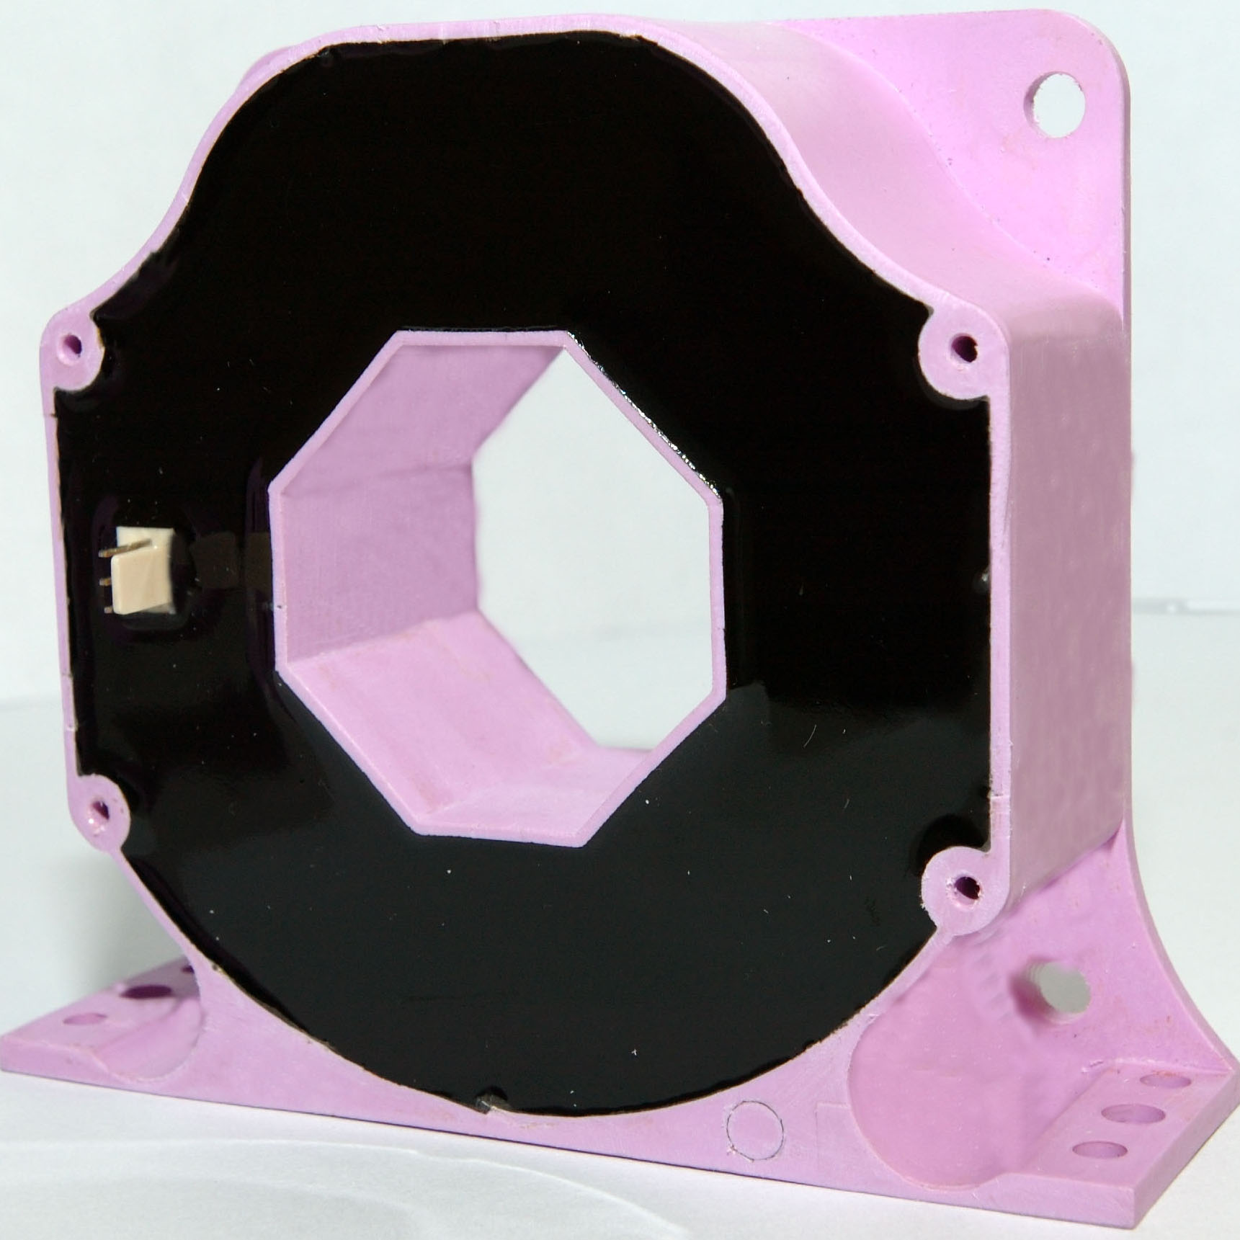

Electrical data
I_{PN} | Primary nominal r.m.s current |  |  | 1000 | A
I_{P} | Primary current, measuring range |  |  | 0…± 1800 | A
R_{M} | Measuring resistance @ T_{A} = 100°C
 |  |  | R_{M min} | R_{M max}
 | with ± 15V | @±1000 A | 0 | 52 | Ω
 |  | @±1100 A | 0 | 3 | Ω
 | with ± 24V | @±1000 A | 0 | 52 | Ω
 |  | @±1800 A | 0 | 3.3 | Ω
I_{SN} | Secondary nominal r.m.s current |  |  | 200 | mA
K_{N} | Conversion ratio |  |  | 1:5000
V_{C} | Supply voltage (± 5%) |  |  | ±15… 24 | V
I_{C C} | Idle Current consumption |  |  | 12(@±24V) | mA
V_{d} | AC isolation test, 50 Hz, 1min |  |  | 3 | kV

Accuracy – Dynamic performance data
X | Accuracy @ I_{PN} , T_{A} = 25°C @ ± 24V (± 5%) f=1kHz | ± 0.40 | %
ε_{L} | Linearity | < 0.15 | %
I_{O} | Offset current @ I_{P} = 0, T_{A} = 25°C  @±100 A_{max}  0  0 | ± 0.40 | mA
I_{OT} | Thermal drift of I_{O} (-10℃…+100℃)  @±100 A_{max} | ± 0.50 | mA
t_{r} | Response time @ 90% of I_{PN} | < 3 | μs
di/dt | di/dt accurately followed | >100 | A/μs
f | Frequency bandwidth (-1 dB) | DC…100 | kHz

General data
R_{s} | Secondary coil resistance @T_{A} = 25°C | 44.4 | Ω
 | @T_{A} = 100°C | 58 | Ω
T_{A} | Ambient operating temperature | -10..+100 | °C
M | Mass | 560 | g
Features
- Closed loop (compensated) current transducer using the Hall-Effect.

Applications
- AC variable speed drives and servo motor drives
- Static converters for DC motor drives
- Battery supplied applications
- Uninterruptible Power Supplies (UPS)
- Switched Mode Power Supplies(SMPS)
- Power supplies for welding applications.
Advantages
- Excellent accuracy
- Very good linearity
- Low temperature drift

Special features
- Connection to secondary circuit on 2510-3Y connector.

* * * * * * * * * * * * * * * * * *
SECONDARY TERMINALS
TERMINAL +：SUPPLY VOLTAGE +15…24V
TERMINAL M：MEASURE
TERMINAL -：SUPPLY VOLTAGE -15…24V

Mechanical Characteristic: General tolerance ± 0.1mm

Remarks
- I_{S} is positive when I_{P} flows in the direction of the arrow.
- Temperature of the primary conductor should not exceed 100 °C.

