CH-C-0550-1601 * CH-C-0550-1601 is a Hall-Effect current transducer.
I_{PN}=550 A
Current Transducer * It can be used for the detection of DC, AC, pulse.
Applications
- AC variable speed drives and servo motor drives
- Static converters for DC motor drives
- Battery supplied applications
- Uninterruptible Power Supplies(UPS)
- Switched Mode Power Supplies (SMPS)
- Power supplies for welding applications.
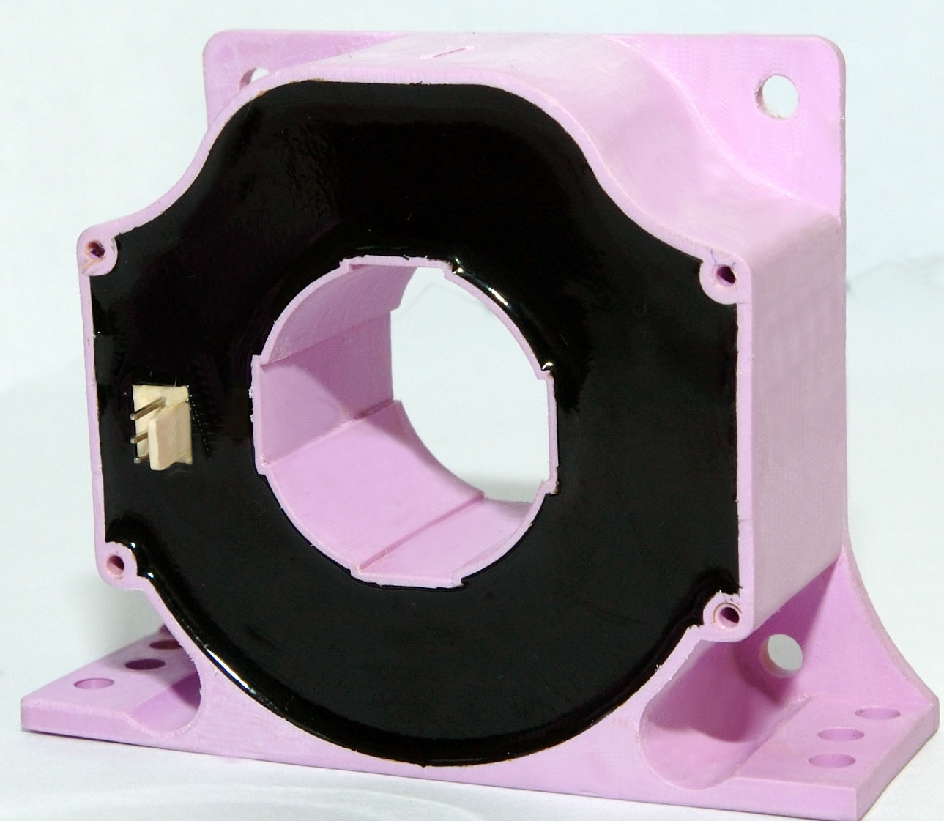
Advantages
- Excellent accuracy
- Very good linearity
- Low temperature drift

Special features
- Connection to secondary circuit
on 2510-3Y connector.

Features
- Closed loop (compensated) current transducer using the Hall-Effect

Electrical data
I_{PN} | Primary nominal r.m.s current |  | 550 | A
I_{P} | Primary current, measuring range |  | 0…± 1650 | A
I_{SN} | Secondary nominal r.m.s current |  | 137.5 | mA
K_{N} | Conversion ratio |  | 1:4000
V_{C} | Supply voltage (± 5%) |  | ± 24 | V
I_{C} | Idle Current consumption |  | 36 | mA
V_{d} | AC isolation test, 50 Hz, 1min |  | 3 | kV
R_{M} | Measuring resistance @ T_{A} = 100°C
 |  |  | R_{M min} | R_{M max}
 | with ± 24V | @±550 A_{max} | 0 110 |  | Ω
 |  | @±1650 A_{max} | 5 5 |  | Ω

Accuracy – Dynamic performance data
X | Accuracy @ I_{PN} , T_{A} = 25°C @ ± 24V (± 5%) |  | ± 0.40 |  | %
ε_{L} | Linearity |  | < 0.15 |  | %
I_{O} | Offset current @ I_{P} = 0, T_{A} = 25°C  @±100 A_{max}  0  0 |  | ± 0.30 |  | mA
I_{OT} | Thermal drift of I_{O} (-10℃…+100℃)  @±100 A_{max} |  | ± 0.40 |  | mA
t_{r} | Response time @ 90% of I_{PN} |  | <3 |  | μs
di/dt | di/dt accurately followed |  | >100 |  | A/μs
f | Frequency bandwidth (-1 dB) |  | DC…100 |  | kHz

General data
T_{A} | Ambient operating temperature | -10..+100 | °C
m | Mass | 222 | g

* * * * * * * * * * * * * * * * * *
SECONDARY TERMINALS
TERMINAL +：SUPPLY VOLTAGE +24V
TERMINAL M：MEASURE
TERMINAL -：SUPPLY VOLTAGE -24V

Remarks
- I_{S} is positive when I_{P} flows in the direction of the arrow.
- Temperature of the primary conductor should not exceed 100 °C.

