CH-C-0300-1601 * CH-C-0300-1601 is a Hall-Effect current transducer.
I_{PN} = 300 A
Current Transducer * It can be used for the detection of DC, AC, pulse.
Applications
- AC variable speed drives and servo motor drives
- Static converters for DC motor drives
- Battery supplied applications
- Uninterruptible Power Supplies(UPS)
- Switched Mode Power Supplies (SMPS)
- Power supplies for welding applications.
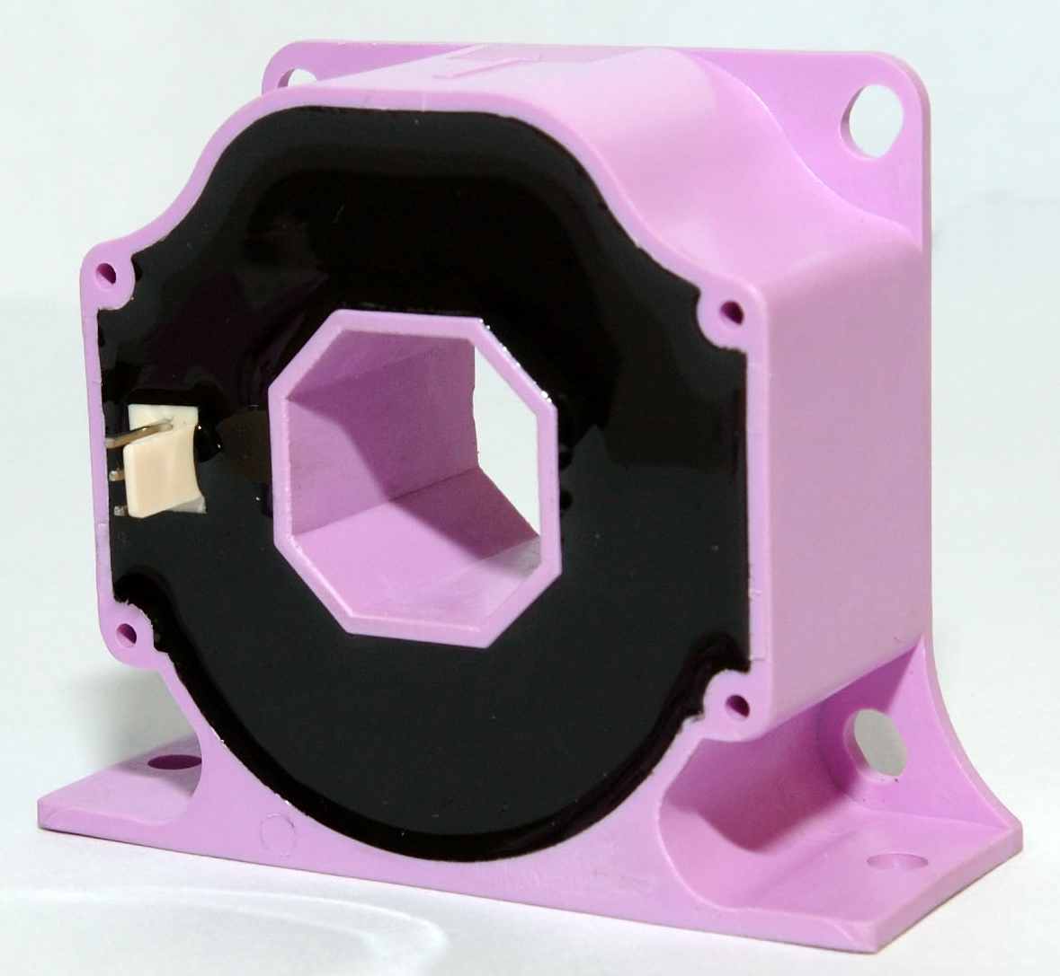

NO PHOTO
Advantages
- Excellent accuracy
- Very good linearity
- Low temperature drift

Special features
- Connection to secondary circuit
on 2510-3Y connector.

Features
- Closed loop (compensated) current transducer using the Hall-Effect

Electrical data
I_{PN} | Primary nominal r.m.s current |  | 300 | A
I_{P} | Primary current, measuring range |  | 0…± 500 | A
I_{SN} | Secondary nominal r.m.s current |  | 150 | mA
K_{N} | Conversion ratio |  | 1:2000
V_{C} | Supply voltage (± 5%) |  | ± 12…± 20 | V
I_{C} | Idle Current consumption |  | 36(@± 15) | mA
V_{d} | AC isolation test, 50 Hz, 1min |  | 3 | kV
R_{M} | Measuring resistance @ T_{A} = 100°C
 |  |  | R_{M min} | R_{M max}
 | with ± 12V | @±300A_{max} | 0 | 45 | Ω
 |  | @±500 A_{max} | 0 | 17 | Ω
 | with ± 20V | @±300 A_{max} | 0 | 95 | Ω
 |  | @±500 A_{max} | 0 | 48 | Ω

Accuracy – Dynamic performance data
X | Accuracy @ I_{PN} , T_{A} = 25°C @ ± 20V (± 5%) | ± 0.40 | %
ε_{L} | Linearity | < 0.15 | %
I_{O} | Offset current @ I_{P} = 0, T_{A} = 25°C  @±100 A_{max}  0  0 | ± 0.20 | mA
I_{OM} | Residual current @ I_{P} = 0, after an overload of 3 × I_{PN}  0 | ± 0.30 | mA
I_{OT} | Thermal drift of I_{O} (-10℃…+100℃)  @±100 A_{max} | ± 0.40 | mA
t_{r} | Response time @ 90% of I_{PN} | <3 | μs
di/dt | di/dt accurately followed | >100 | A/μs
f | Frequency bandwidth (-1 dB) | DC…100 | kHz

General data
T_{A} | Ambient operating temperature | -10..+100 | °C
m | Mass | 120 | g
* * * * * * * * * * * * * * * * * *
SECONDARY TERMINALS
TERMINAL +：SUPPLY VOLTAGE +12…20V
TERMINAL M：MEASURE
TERMINAL -：SUPPLY VOLTAGE -12…20V

Remarks
- I_{S} is positive when I_{P} flows in the direction of the arrow.
- Temperature of the primary conductor should not exceed 100 °C.

