CH-C-0100-0001 * CH-C-0100-0001 is a Hall-Effect current transducer.
I_{PN} = 100 A
Current Transducer * It can be used for the detection of DC, AC, pulse.
Applications
- AC variable speed drives and servo motor drives
- Static converters for DC motor drives
- Battery supplied applications
- Uninterruptible Power Supplies(UPS)
- Switched Mode Power Supplies (SMPS)
- Power supplies for welding applications.
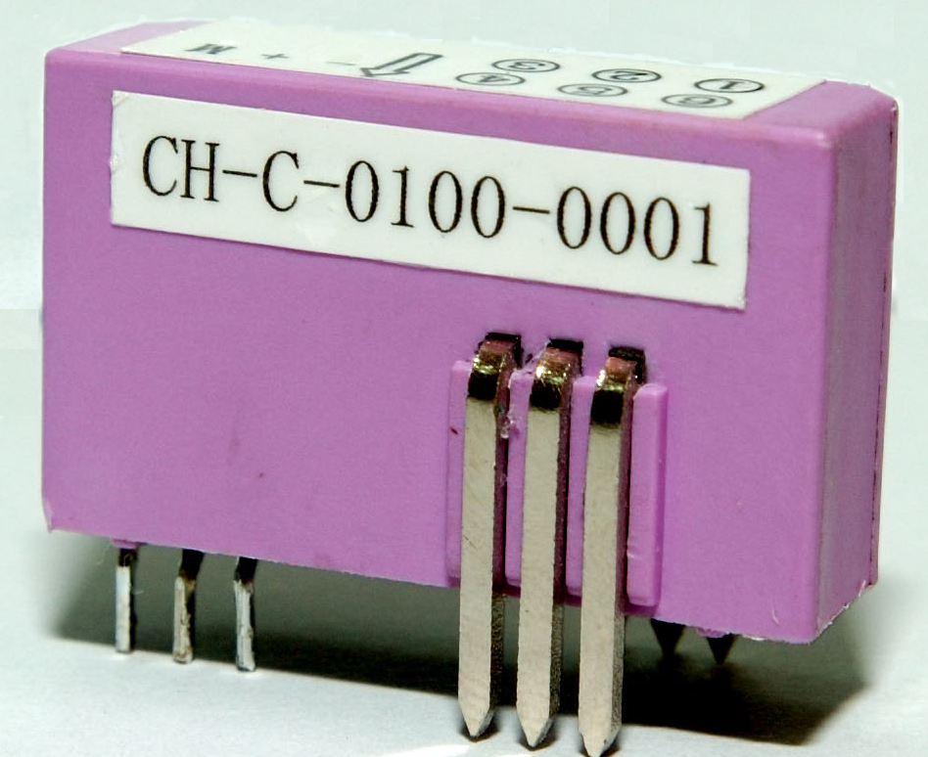
Advantages
- Excellent accuracy
- Very good linearity
- Low temperature drift

Special features
- Printed circuit board mounting.

Features
- Closed loop (compensated) current transducer using the Hall-Effect

Electrical data
I_{PN} | Primary nominal r.m.s current |  |  |  |  |  |  | 100 | A
I_{P} | Primary current, measuring range |  |  |  |  |  |  | 0…± 160 | A
I_{SN} | Secondary nominal r.m.s current |  |  |  |  |  |  | 50 | mA
K_{N} | Conversion ratio |  |  |  |  |  |  | 1-2-3:2000
V_{C} | Supply voltage (± 5%) |  |  |  |  |  |  | ± 12…± 15 | V
I_{C} | Idle Current consumption |  |  |  |  |  |  | 15 (@± 15) | mA
V_{d} | AC isolation test, 50 Hz, 1min |  |  |  |  |  |  | 3 | kV
R_{M} | Measuring resistance @ |  |  |  | T_{A} = 100°C
 |  |  |  |  | R_{M min} |  |  |  | R_{M max}
 | with ± 12V | @±100A_{max} |  |  | 0 |  |  |  | 100 | Ω
 |  | @±160 A_{max} |  |  | 0 |  |  |  | 19 | Ω
 | with ± 15 V | @±100 A_{max} |  |  | 0 |  |  | 157 |  | Ω
 |  | @±160A_{max} |  |  | 0 |  |  | 54 |  | Ω

Accuracy – Dynamic performance data
X | Accuracy @ I_{PN} , T_{A} = 25°C | @ ± 24V (± 5%) |  |  |  | ± 0.40 |  |  |  | %
ε_{L} | Linearity |  |  |  |  | < 0.15 |  |  |  | %
I_{O} | Offset current @ I_{P} = 0, T_{A} = 25°C  @±100 A_{max}  0  0 |  |  |  |  | ± 0.20 |  |  |  | mA
I_{OM} | Residual current @ I_{P} = 0, after an overload of 3 × I_{PN}  0 |  |  |  |  | ± 0.30 | mA
I_{OT} | Thermal drift of I_{O}  @±100 A_{max} | (-10℃…+100℃) |  |  |  | ± 0.40 |  |  |  | mA
t_{r} | Response time @ 90% of I_{PN} |  |  |  |  | <3 |  |  |  | μs
di/dt | di/dt accurately followed |  |  |  |  | >100 |  |  | A/μs
f | Frequency bandwidth (-1 dB) |  |  |  |  | DC…100 |  |  | kHz

General data
T_{A} | Ambient operating temperature |  | -10..+100 | °C
m | Mass |  | 28 | g

* * * * * * * * * * * * * * * * * *

SECONDARY TERMINALS
TERMINAL +：SUPPLY VOLTAGE +12…15V
TERMINAL M：MEASURE
TERMINAL -：SUPPLY VOLTAGE -12…15V

PRIMARY TERMINALS 1-3：IN
PRIMARY TERMINALS 4-6：OUT

Remarks
- I_{S} is positive when I_{P} flows in the direction of the arrow.
- Temperature of the primary conductor should not exceed 100 °C.

