Current Transducer CH-C-0017-0401
I_{PN} = 17 A
* CH-C-0017-0401 is a Hall-Effect current transducer .
* It can be used for the detection of DC, AC, pulse.
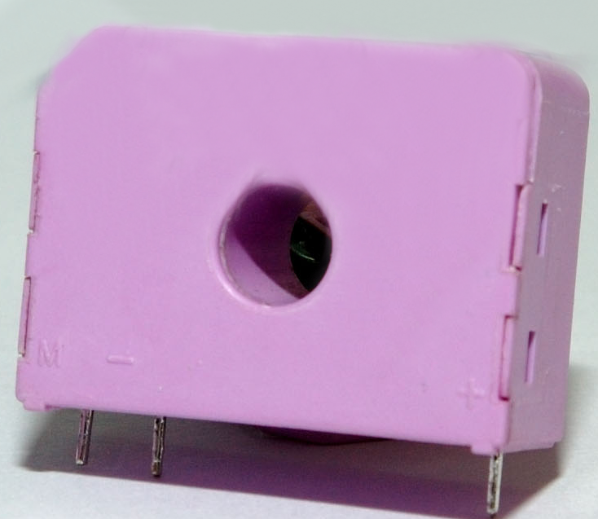

Electrical data
I_{PN} | Primary nominal r.m.s current |  |  | 17 | A
I_{P} | Primary current, measuring range |  |  | 0…+32 | A
R_{M} | Measuring resistance @ T_{A} =100°C
 |  |  | R_{M min} | R_{M max}
 | with ± 12 V | @±50A_{max} | 0 | 219.84 | Ω
 |  | @±80 A_{max} | 0 | 147.84 | Ω
 | with ± 15 V | @±50 A_{max} | 0 | 279.84 | Ω
 |  | @±80 A_{max} | 0 | 167.34 | Ω
I_{SN} | Secondary nominal r.m.s current |  |  | 34 | mA
K_{N} | Conversion ratio |  |  | 1:500
V_{C} | Supply voltage (± 5%) |  |  | +12…15 | V
I_{C} | Idle current consumption |  |  | 15(@+15V) | mA
V_{d} | AC isolation test, 50 Hz, 1min |  |  | 3 | kV

Accuracy – Dynamic performance data
X | Accuracy @ I_{PN} , T_{A} = 25°C @ + 15V (± 5%) f=1kHz | ± 0.40 | %
ε_{L} | Linearity | < 0.15 | %
I_{O} | Offset current @ I_{P} = 0, T_{A} = 25°C  @±100 A_{max}  0  0 | ± 0.20 | mA
I_{OM} | Residual current @ I_{P} = 0, after an overload of 3 × I_{PN}  0 | ± 0.30 | mA
I_{OT} | Thermal drift of I_{O} (-10℃…+100℃)  @±100 A_{max} | ± 0.40 | mA
t_{r} | Response time @ 90% of I_{PN} | < 3 | μs
di/dt | di/dt accurately followed | >100 | A/μs
f | Frequency bandwidth (-1 dB) | DC…200 | kHz

General data
T_{A} | Ambient operating temperature | -10..+100 | °C
M | Mass | 20 | g
Features
- Closed loop (compensated) current transducer using the Hall-Effect
Advantages
- Excellent accuracy
- Very good linearity
- Low temperature drift

Applications
- AC variable speed drives and servo motor drives
- Static converters for DC motor drives
- Battery supplied applications
- Uninterruptible Power Supplies (UPS)
- Switched Mode Power Supplies(SMPS)
- Power supplies for welding applications.

Special features
- Printed circuit board mounting.

.

* * * * * * * * * * * * * * * * * *
SECONDARY TERMINALS
TERMINAL +：SUPPLY VOLTAGE +12…15V
TERMINAL M：MEASURE

Mechanical Characteristic: General tolerance ±0.1mm
Remarks

- I_{S} is positive when I_{P} flows in the direction of the arrow.
- Temperature of the primary conductor should not exceed 100 °C.

