CH-C-0006-0201 * CH-C-0006-0201 is a Hall-Effect current transducer.
I_{PN} = 6 A
Current Transducer * It can be used for the detection of DC, AC, pulse.

Applications
- AC variable speed drives and servo motor drives
- Static converters for DC motor drives
- Battery supplied applications
- Uninterruptible Power Supplies(UPS)
- Switched Mode Power Supplies (SMPS)
- Power supplies for welding applications.
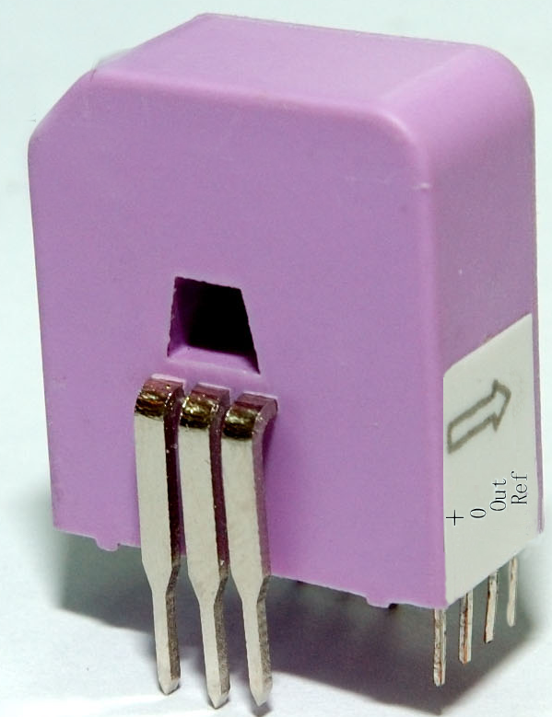

Advantages
- Excellent accuracy
- Very good linearity
- Low temperature drift

Special features
- Printed circuit board mounting.
- Unipolar voltage supply.

Features
- Closed loop (compensated) current transducer using the Hall-Effect

Electrical data
I_{PN} | Primary nominal r.m.s current |  |  |  |  |  | 6 |  | A
I_{P} | Primary current, measuring range |  |  |  |  |  | 0…± 18① |  |  | A
Vout | Analog output voltage @ Ip  Ip=0 |  |  |  |  |  | 2.5±(0.625·I_{P} / I_{PN}) |  |  | V
 | Ip=0 |  |  |  |  |  | 2.5±0.025②  2.5 |  |  | V
VREF | Voltage reference (external reference),refin mode |  |  |  |  |  | 1.9…2.7③ |  |  | V
Ns | Number of secondary turns (±0.1%) |  |  |  |  |  | 2000
RL | Load resistance |  |  |  |  |  | ≥2 | kΩ
V_{C} | Supply voltage (± 5%) |  |  |  |  |  | 5 |  | V
I_{C} | Idle Current consumption |  |  |  |  |  | 20 |  | mA
V_{d} | AC isolation test, 50 Hz, 1min |  |  |  |  |  | 3 |  | kV

Accuracy – Dynamic performance data
X | Accuracy @ I_{PN} , T_{A} = 25°C | 5V (± 5%) |  |  |  | 0.20 |  |  |  | %
ε_{L} | Linearity error |  |  |  |  | < 0.15 |  |  |  | %
 | Offset current @ I_{P} = 0, T_{A} = 25°C  @±100 A_{max}  0  0 |  |  |  |  | 0.60 |  |  |  | %
V_{OM} | Residual current @ I_{P} = 0, after an overload of 3 × I_{PN}  0 |  |  |  |  | ± 0.4 | mV
tra | Response time @ 10% of I_{PN} |  |  |  |  | <200 |  |  |  | ns
di/dt | di/dt accurately followed |  |  |  |  | >100 |  |  | A/μs
f | Frequency bandwidth (-1 dB) |  |  |  |  | DC…200 |  |  | kHz

General data
T_{A} | Ambient operating temperature |  | -10..+100 | °C
m | Mass |  | 12 | g
Notes: ① Only in refout mode or with external REF less than 2.525V and greater than 2.475V .② VOUT is linked to VREF ,by conception the difference between these two nodes for IP=0 is maximum ±25mV , 2.475<VOUT<2.525V③ To overdrive the REF (1.9…2.7V) max. ±1mA is needed.④The primary winding is with 3 wires parallel.

Remarks
- VOUT is positive when Ip flows from terminals 1,2,3 to terminals 4,5,6
- This is a standard model .For different versions (supply voltages,turns ratios,unidirectional
measurements….), please contact us.

